

**UNIVERSITY OF ASIA PACIFIC**

***Department of Computer Science and Engineering***

*A*

*PROJECT ON*

**ONLINE BOOK STORE**

*For partial fulfillment of the requirement for the Degree of Bachelor of Science in Computer Science and Engineering.*

**SUBMITTED BY : SUBMITTED TO:**

**Mohammad Tipu Sultan Dr.Nasima Begum**

**Reg.No: 15101036 Assistant Professor**

**Section: A2 Department of CSE**

**University of Asia Pacific**

***DATA***

***REPORT***

***ACKNOWLEDGEMENT***

First and foremost we would like to express our gratitude to our guide ***DR.NASIMA BEGUM***  mam & other faculty member for giving us wonderful opportunity to work on the project. We are very thankful to him who was always ready to lend their helping hand to us. This project has giving us fair exposure to some of the very interesting features of ***“ONLINE BOOK STORE”*** and ***“PHP”*** along beyond doubt it will help us in the short and long run. We are very grateful to him introducing me to some of very exciting features of ***“ONLINE BOOK STORE”.***

We are also thankful to all my teachers of ***UNIVERSITY OF ASIA PACFIC.*** Who were simply full ideas and whenever there was any need they shared those great ideas and concept with us. And in the end, we would like to thank all those who helped us during the testing phase of the project.

THAKING YOU………

***“ONLINE BOOK STORE”***

***INDEX***

|  |  |  |
| --- | --- | --- |
| ***Sr no.*** | ***Topics*** | ***Page no.*** |
| ***1.*** | ***Introduction*** | ***6*** |
| ***2.*** | ***Objective*** | ***7*** |
| ***3.*** | ***Hardware requirement*** | ***8*** |
| ***4.*** | ***A Word about PHP*** | ***9*** |
| ***5.*** | ***E – R diagram*** | ***10*** |
| ***6.*** | ***Project layout*** | ***11*** |
| ***7.*** | ***Benefits*** | ***12*** |
| ***8.*** | ***Project details*** | ***13-18*** |
| ***9.*** | ***Futuristic scope*** | ***19*** |
| ***10.*** | ***Conclusion*** | ***20*** |

***INTRODUCTION***

## Shopping Cart System

**Use of Shopping Cart system**

Shopping Cart System is the Simple shopping Solution. It's a full-featured website and shopping cart system that bends over backwards to give you the flexibility you need to run your online store.

**What is Shopping Cart system?**

Online Book Store is a form of electronic shopping store where the buyer is directly online to the seller's computer usually via the internet.

**Administrator** of Shopping Cart System has multiple features such as Add, Delete, Update shopping Items.

**Brief overview of the technology:**  
Front end: HTML, CSS

1. HTML: HTML is used to create and save web document. E.g. Notepad/Notepad++
2. CSS : (Cascading Style Sheets) Create attractive Layout

Back end: PHP, MySQL

1. PHP: Hypertext Preprocessor (PHP) is a technology that allows software developers to create dynamically generated web pages, in HTML, XML, or other document types, as per client request. PHP is open source software.
2. MySQL: MySql is a database, widely used for accessing querying, updating, and managing data in databases.

**Software Requirement(any one):**

* XAMPP Server

**Admin login details:** Login Id : tipu  
 Password : 123

***OBJECTIVE***

Starting the project, we should fully know about the meaning of project. There are seven letters in the word ***“PROJECT”.*** Each character has its own technical meaning.

***P – planning :*** this deals with the idea at thinking and which are required for project.

***R – Resource :*** the money problem will be solved and resources from which collected.

***O – Operating :*** the procedure from which getting job is prepared in a systematic way is known as operation.

***J – Joint effort :*** this is directly proper to a operation output is a made of several person working sincerely is known as JOIN EFFORT.

***E – Engineering : A*** well educated engineer can do this work in a better way to find out better result. Hence the project is as engineer function.

***C – Cooperation :*** To make the project successfully, it is necessary for its success and completion of project.

***T – Technique :*** It must as it gives a better shape. It is not possible to complete the project without technique.

***The project is a system that gives the systematic way of planning and working.***

***Or***

***It representing the temporary task, in a scientific manner carried out of engineers to achieve a goal.***

***HARDWARE***

***REQUIREMENT***

Hardware requirement of project are :

|  |  |
| --- | --- |
| **Section** | **Requirements and Recommendations** |
| Supported Operating Systems | Microsoft Windows 7 32/64 bit  Microsoft Windows 8 32/64 bit |
| Additional Software Requirements | Adobe Acrobat Reader 4.0 or higher |
| Display | Minimum resolution 800 x 600 pixel  1024 x 768 pixel recommended |
| RAM | 2 GB or more  4 GB or more recommended especially for Microsoft Windows Vista, 7 and 8 |
| CPU | 1.5 GHz processor speed or higher |

***A WORD ABOUT PHP***

## What is PHP?

PHP (Hypertext Preprocessor) is a widely-used open source general-purpose scripting language that is especially suited for web development and can be embedded into HTML.

PHP is an acronym for "PHP: Hypertext Preprocessor". PHP is a widely-used, open source scripting language. PHP scripts are executed on the server. PHP is free to download and use

**What is a PHP File?**

PHP files can contain text, HTML, CSS, JavaScript, and PHP code. PHP code are executed on the server, and the result is returned to the browser as plain HTML. PHP files have extension ".php"

**Why PHP?**

PHP runs on various platforms (Windows, Linux, Unix, Mac OS X, etc.) PHP is compatible with almost all servers used today (Apache, IIS, etc.) PHP supports a wide range of databases. PHP is free. Download it from the official PHP resource: [www.php.net](http://www.php.net/). PHP is easy to learn and runs efficiently on the server side

## How Can We Set Up PHP on Your Own PC :

However, if your server does not support PHP, you must:

Install a web server

Install PHP

Install a database, such as MySQL

The official PHP website (PHP.net) has installation instructions for PHP: <http://php.net/manual/en/install.php>

***E – R DIAGRAM***

Entity Relationship Diagrams are a major data modeling tool and will help organize the data in your project into entities and define the relationships between the entities. This process has proved to enable the analyst to produce a good database structure so that the data can be stored and retrieved in a most efficient manner.

**Entity**

A data entity is anything real or abstract about which we want to store data. Entity types fall into five classes: roles, events, locations, tangible things or concepts. E.g. employee, payment, campus, book. Specific examples of an entity are called **instances.** E.g. the employee John Jones, Mary Smith's payment, etc.

**Relationship**

A data relationship is a natural association that exists between one or more entities. E.g. Employees process payments. .

**Attribute**   
A data attribute is a characteristic common to all or most instances of a particular entity. Synonyms include property, data element, field. E.g. Name, address, Employee Number, pay rate are all attributes of the entity employee. An attribute or combination of attributes that uniquely identifies one and only one instance of an entity is called a **primary key** or **identifier**. E.g. Employee Number is a primary key for Employee.

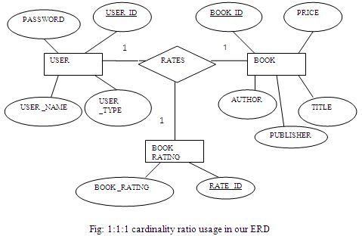

***PROJECT LAYOUT***

***PROJECT PLAN:***

The Project Plan (sometimes called project initiation document or project scoping report) is produced by the Project Manager following a brief Scoping Project Study. It should establish:

What the project is to achieve

A detailed time schedule for carrying out the project

Details of the resources required - people, money, sections

Who is to be involved in the project

What the risks and implementation issues are.

 A typical format is given below. As you may notice, the first five items (Part A) focus on what the project is to achieve whilst the last four items (Part B) go into more depth about how the project should be carried out.

###### Project Plan

### Part A

1.    Title of project,   
2.    Background to the Project  
3.    Terms of Reference & Key Objectives  
4.    Benefits & Costs Analysis  
5.    Risk Assessment

### Part B

6.    Resources likely to be needed  
7.    Costs  
8.    Proposed Project Organisation  
9.    Time Schedule

***BENEFITS***

20 years ago, blogs didn’t exist. Today, there are over 150 million of them.

Still, I get a lot of puzzled looks when I tell people that having a blog is the single most important thing a business, cause, or person can do to advance online. Even though ‘blogging’ has hit it big, most people don’t get what makes blogging so powerful, helpful, and beneficial.

To put an end to that, I’ve compile a list of the 20 biggest benefits of having a blog below. If you’re among the uninitiated, prepare to be enlightened. If you’ve already started a blog of your own then you can consider this an affirmation of why you do what you — and a good place to direct people who still think that a blog is just a pointless public diary.

***PROJECT DETAILS***

***There are two views of this Online Bookshop:***

***1. ADMINISTRATOR VIEW :***



***2.  USER VIEW :***



***Sign in:***

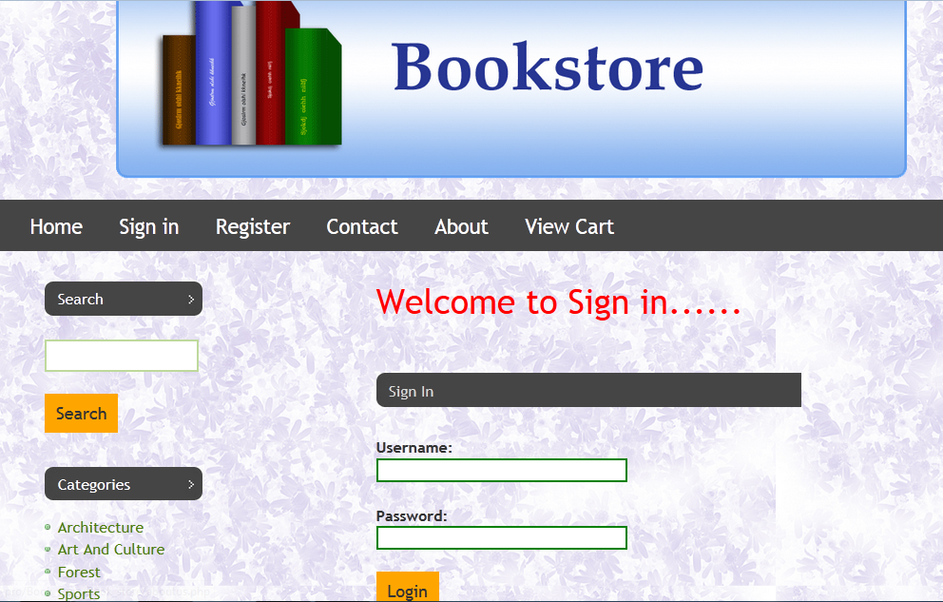

***Registration :***

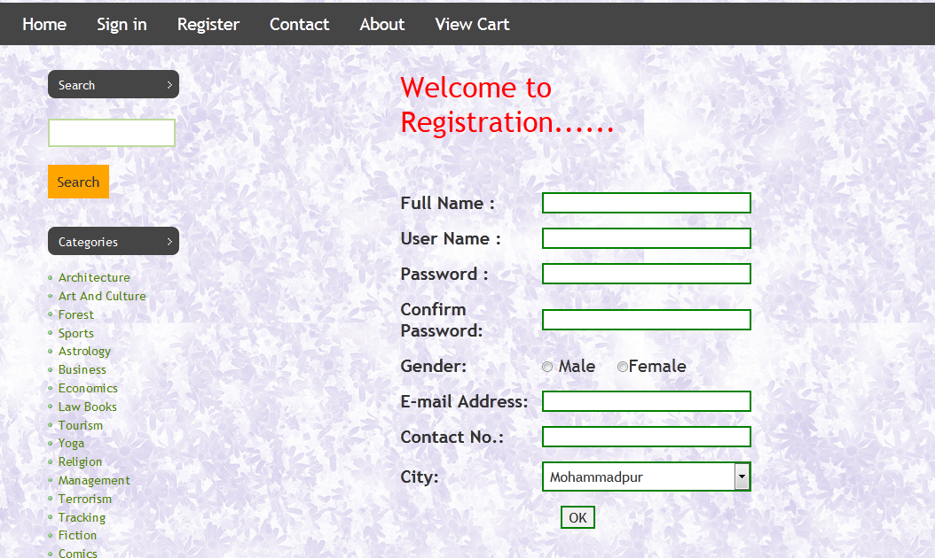

***View Cart :***

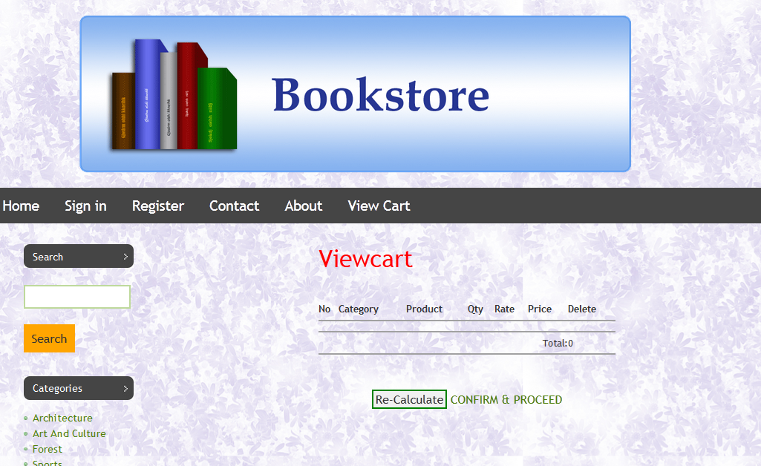

***ADMIN CODE…***

*Index.php--*

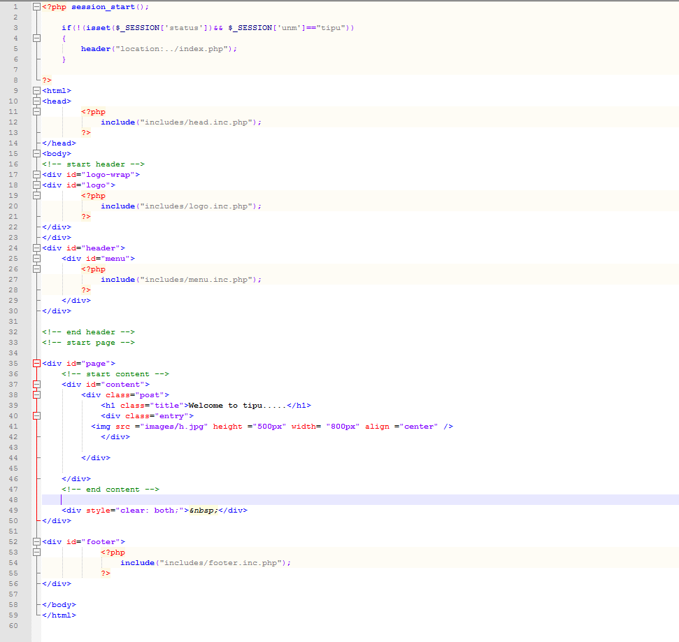

***USER CODE…***

*Index.php****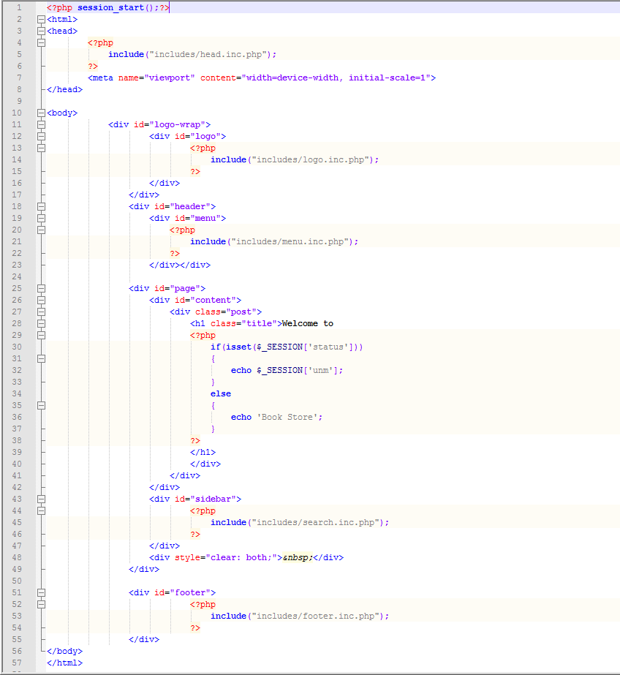Database :***

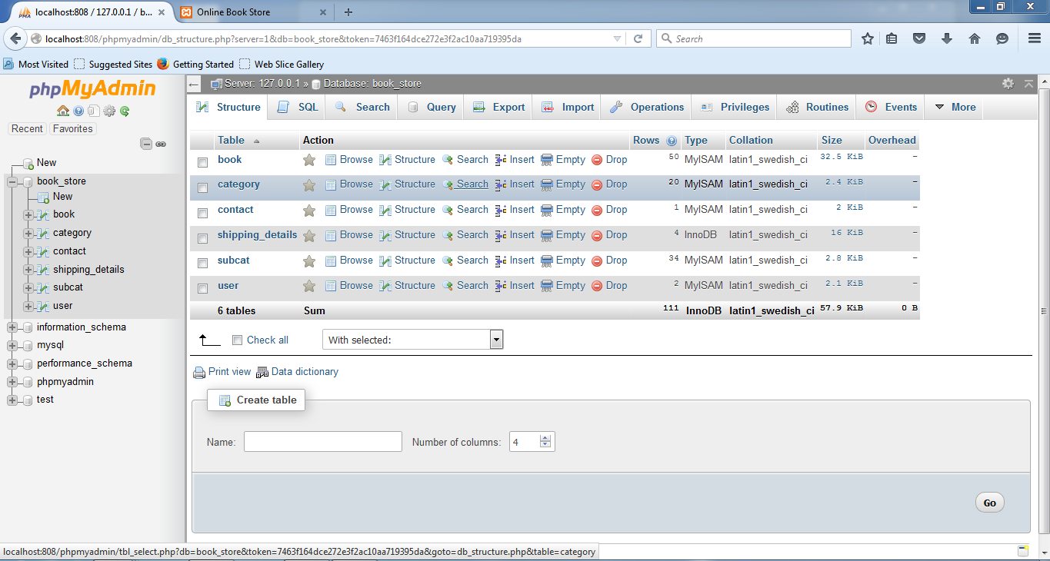

***FUTURE SCOPE***

This project can be easily implemented under various situations. We can add new features as and when we require. Reusability is possible as and when require in this project. There is flexibility in all the modules. We can also include online payment services to this project using PayPal. This will help customers to pay online for their purchases using Credit/Debit card. There are many features which could be added to this project for making this project more productive.

***CONCLUSION***

The software development is never completed. There is always a need for modification. Online Book store is an online web application where the customer can purchase books online.

Through a web browser the customers can search for a book by its title or author, later can add to the shopping cart and finally purchase the books.

***REFERENCES***

1.www.google.com

2. [www.w3schools.com/html](http://www.w3schools.com/html)

3. [www.tutorialspoint.com](http://www.tutorialspoint.com)

4. [www.phppoint.com](http://www.phppoint.com/)

5. [www.Youtube.com](http://www.Youtube.com)

***THANK***

***YOU***